**LPG Storage Tank**

***By: Saroj Basnet(077BME037)***

|  |  |
| --- | --- |
|  | |
| **Specification** | **Value** |
| Capacity | 1000 Ltr + |
| Type | Horizontal Cylindrical with Torispherical Ends |
| Outer Diameter (D) | 1.0 m |
| Straight Cylinder Length (Lc) | 1.28 m |
| Total Tank Length (Lt) | 1.78 m (including end caps) |
| Wall Thickness (t) | 10 mm |
| End Cap Type | Torispherical |
| End Cap Depth (h) | 0.3 m (on both sides) |
| Shell Material | Stainless Steel 304 |
| Inside Pressure | 15 bar |
| LPG density | 530 kg/m^3 |
| Liquid LPG Level | 0.4 m high from center of cylinder |

**Gemoetry:**

In SolidWorks 2024

Side view:

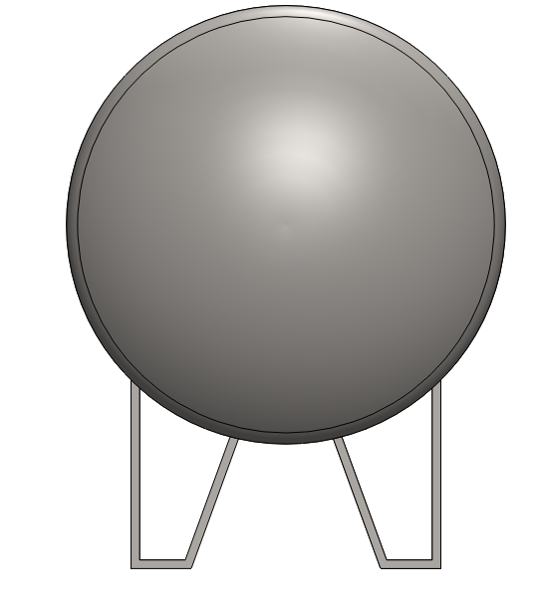

Front View:

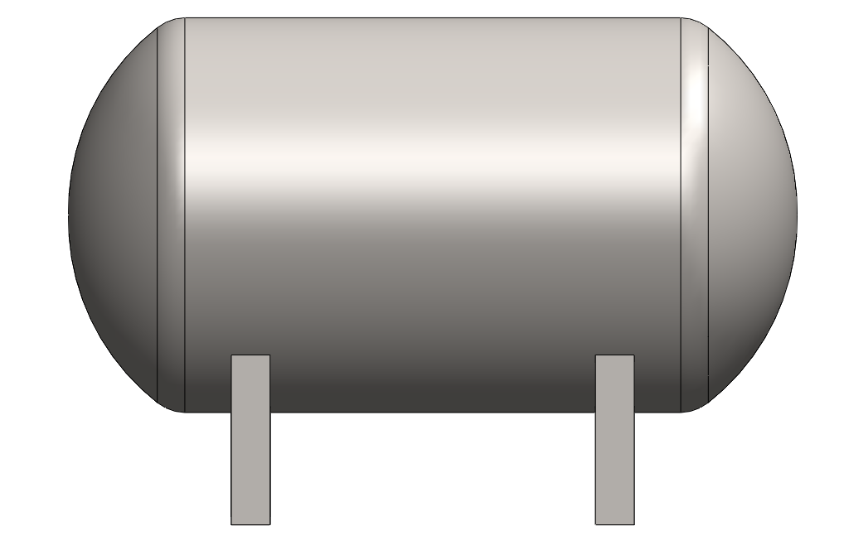

Isometric view:

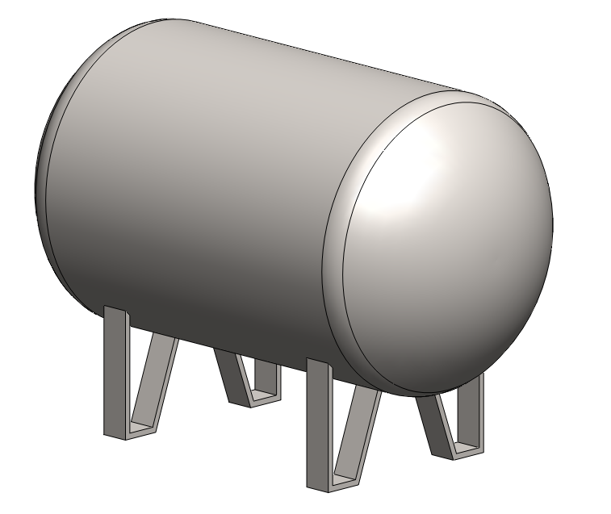

**Simulation:**

In ANSYS 2024R1.

Material: Stainless steel

Bottom face of 4 leg is fixed.

Atmospheric pressure is applied from outer surfaces.

Standard earth gravity and Hydrostatic pressure is applied.

**Deformation:**

Maximum deflection: 3.3117e-004 m at center of Torispherical face.

Average deflection: 1.9081e-004 m

Scale: 1(true scale)

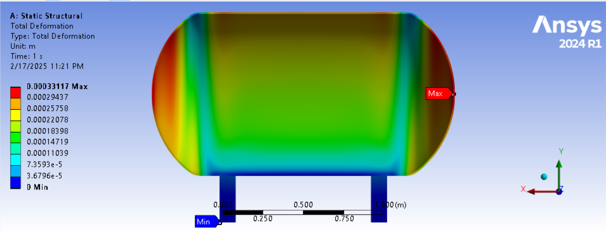

Scale: 200x

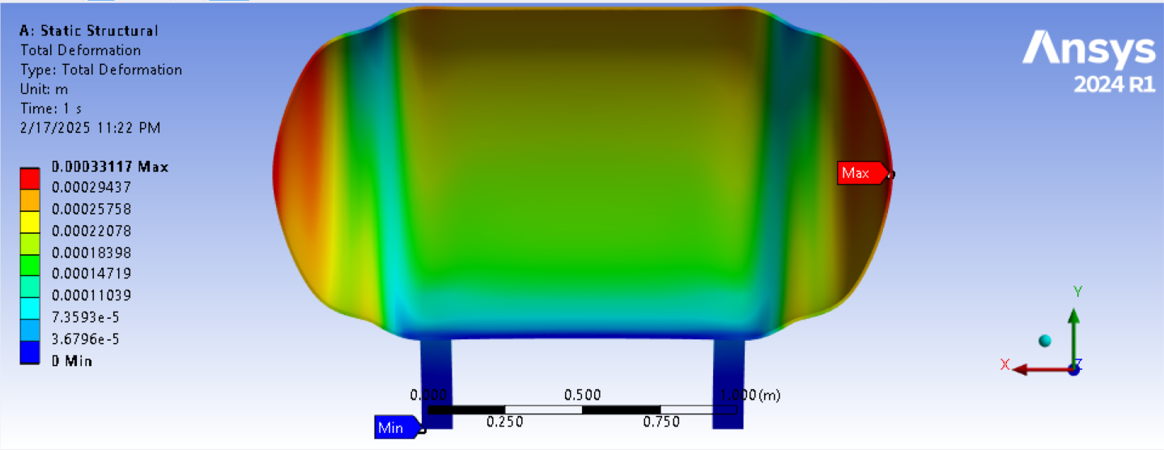

Isometric view.

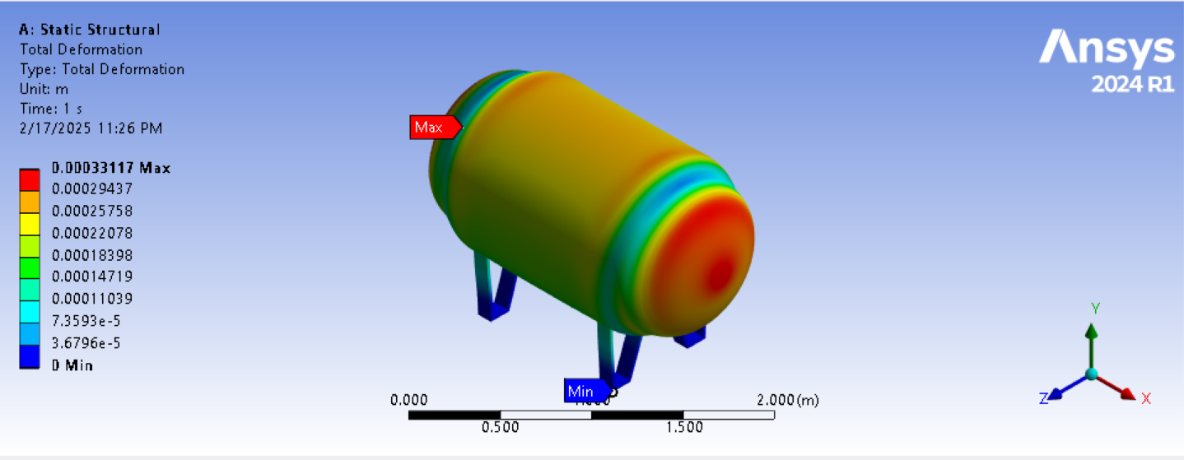

**Stress:**

